PRACTICAL-4
- Create Books Table:
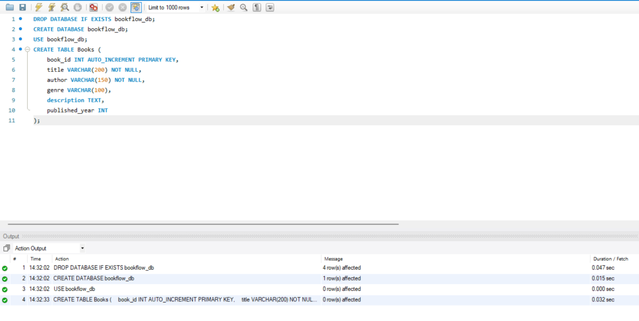
- Insert Initial Book Data:
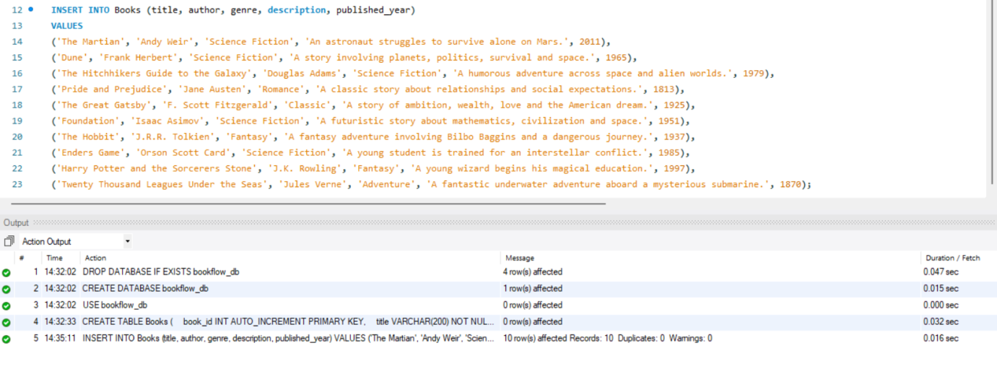
- Add JSON Vector Column & Populate Mock Embeddings:
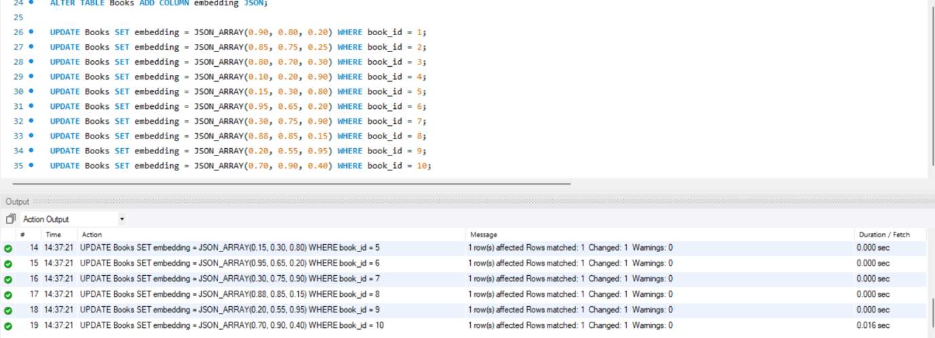
- Perform L2 Distance Search
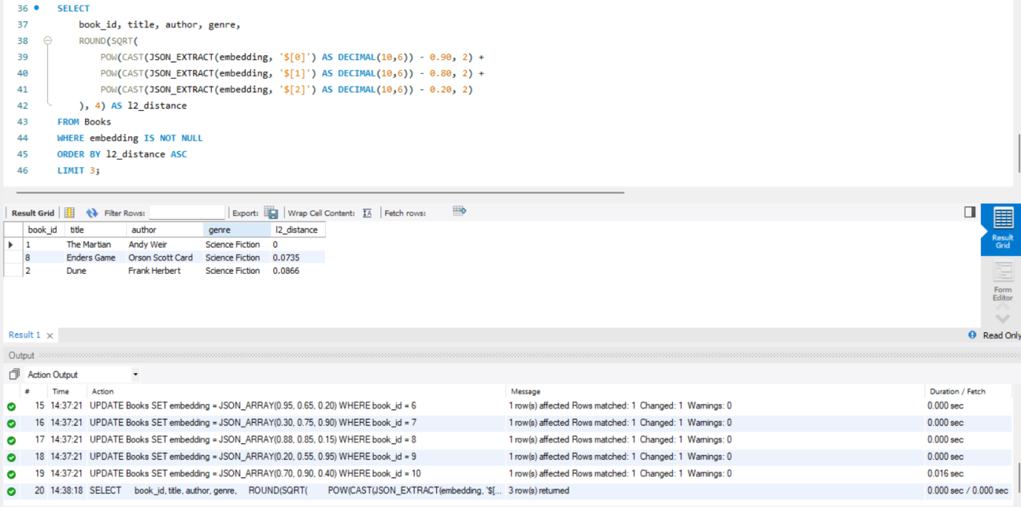
- Perform Cosine Similarity Search:
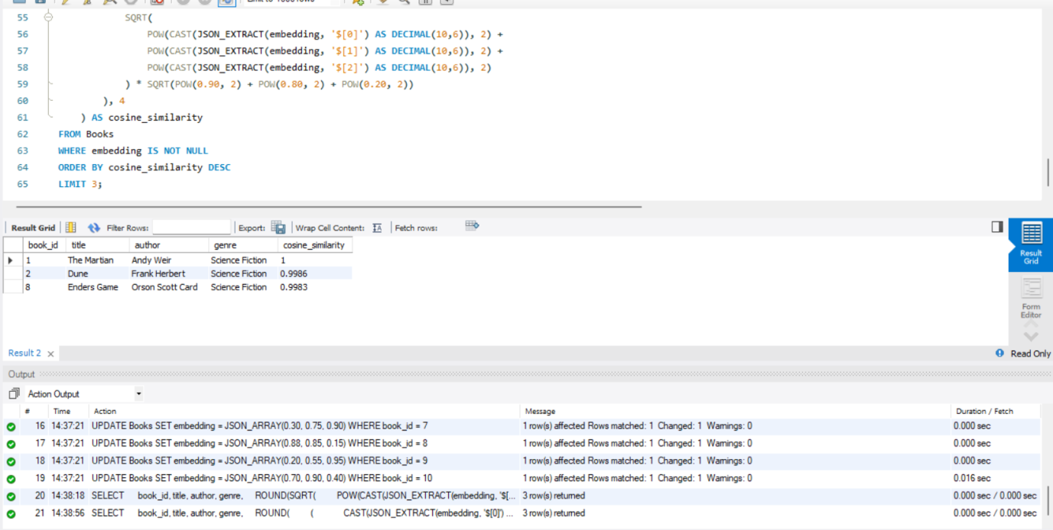
- Perform Cosine Similarity Search:
